Python Module 1 Notes (step 8 onwards)

* Slicing
  + 
* 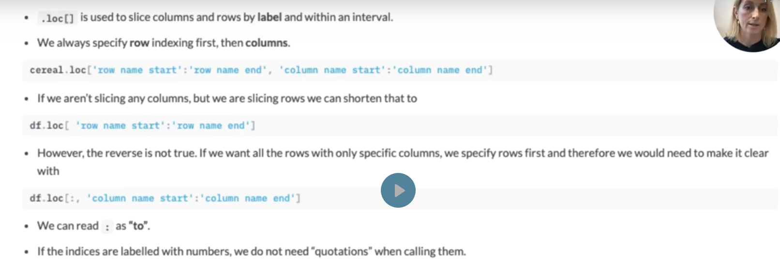
* Obtaining dataframe values—cereal.loc[63, ‘calories’]—specifies value contained in a specific cell
* Select a single column
  + Cereal.loc[:, [‘type’]] OR cereal[[‘type’]]
* Slicing and selecting using .iloc
  + I=index integer position
  + E.g. cereal.iloc[2:5]
    - Note excludes upper bound
    - 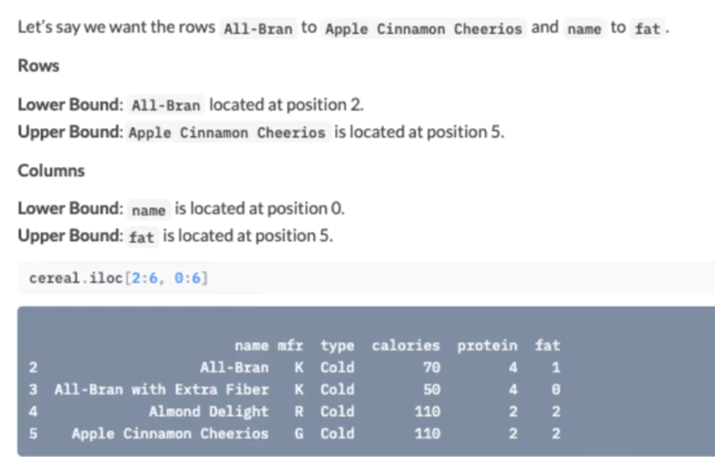
    - 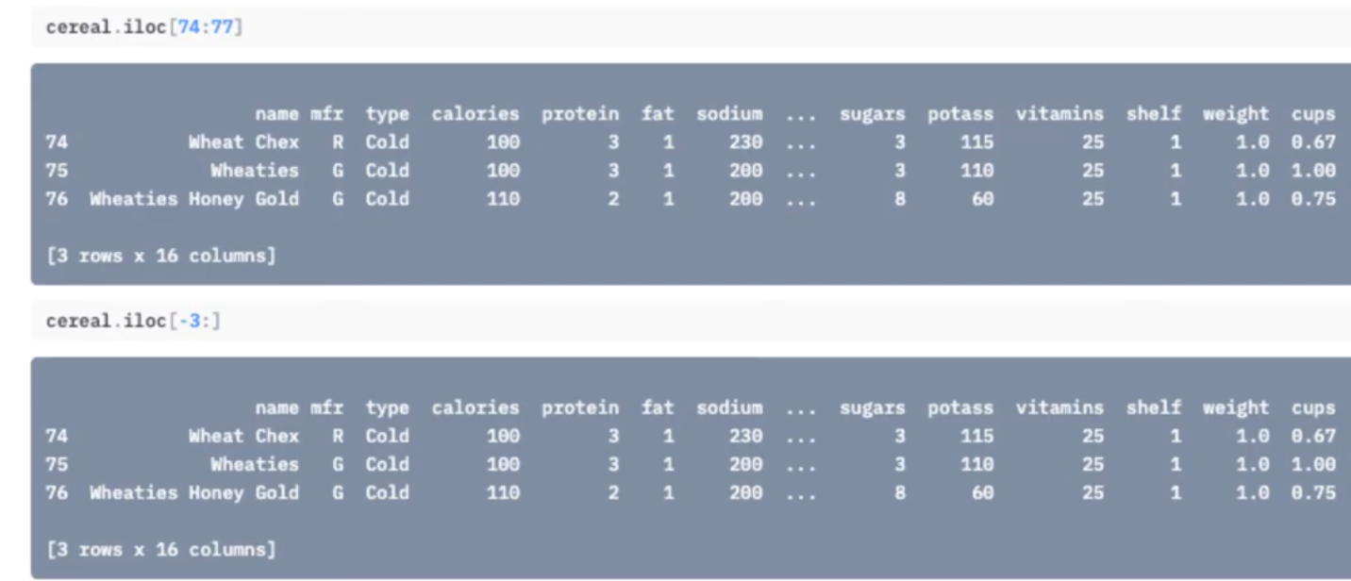
    - .iloc works only with integers, no names in ‘’ or “”
    - 

Sorting dataframes

* E.g. creal
  + - 
    - 
* Summary statistics
  + Categorical
  + Numerical
  + 
  + 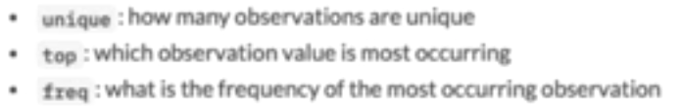
  + 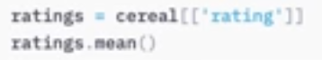
  + 
* Frequency tables
  + Frequency table—displays number of occurrences for each value in a table
  + E.g. mfr_column = cereal[‘mfr’]—only use [] for columns
  + 
* Saving a dataframe
  + 
  + 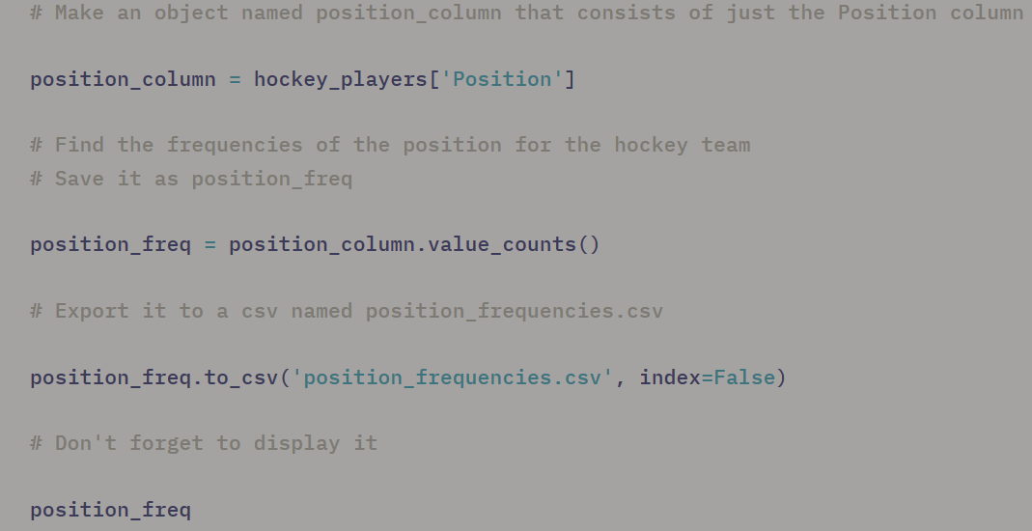
* Altair
  + 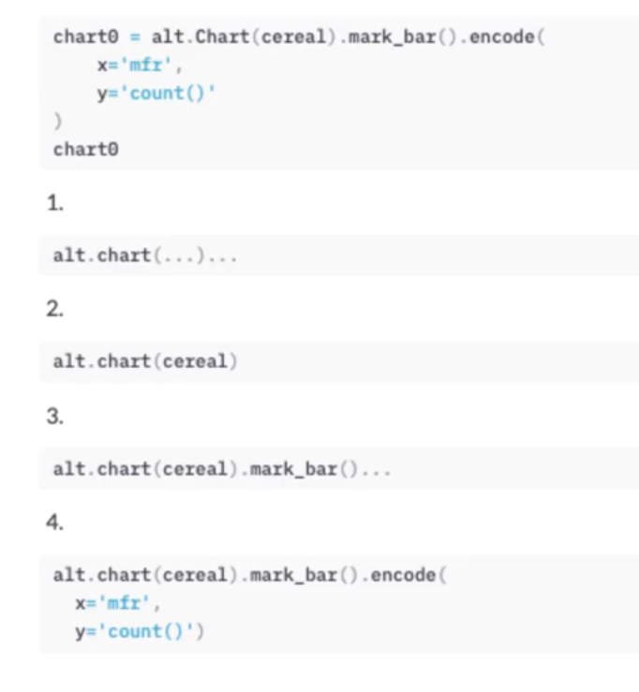
  + 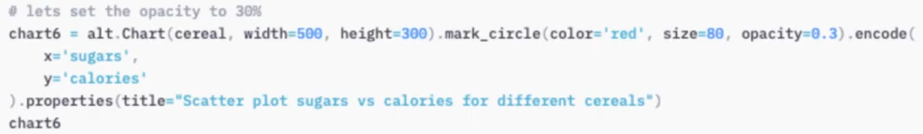
  + 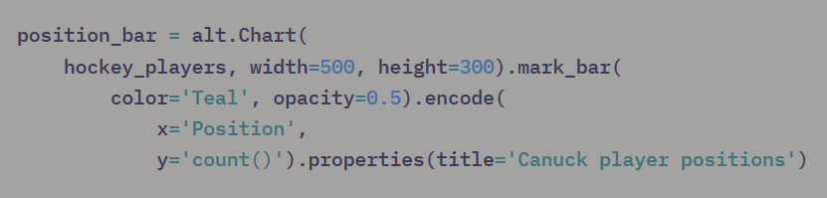
    - Alt.chart= altair chart
    - Hockey_players = file name
    - Mark_bar – creates bar graph